**Werfel, Franz (1890-1945)**

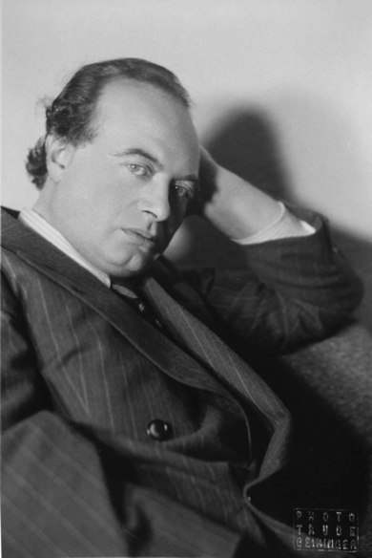Franz Viktor Werfel was a Jewish-born Austrian novelist, poet, and playwright best known for his works of historical fiction, including *The Forty Days of Musa Dagh* (1933) and *The Song of Bernadette* (1943). Werfel also greatly contributed to the development of expressionist poetry in the German language, and in 1929, he was awarded the Grillparzer Prize by the Austrian Academy of Sciences for his dramatic work. Very well connected within the literary scene, Werfel married Alma Mahler in 1929. The couple relocated to Los Angeles in 1938, and several of Werfel’s works were subsequently turned into films. Werfel died of a heart attack in August of 1945.

Born in Prague on September 10, 1890, Franz Werfel was the eldest child of Rudolf Werfel, the owner of a glove factory, and Albine Kussi, the daughter of a wealthy mill owner. Although he was raised in the Jewish tradition of his parents, Werfel was likewise heavily influenced by the Catholicism of his family’s cook and nursemaid, Barbara Šimůnková (“Bábi”), who regularly took Werfel to Catholic Mass. Indeed, as a boy, Werfel attended a school run by Piarists, a Catholic educational order that nonetheless allowed a Rabbi to instruct the Jewish students in religious matters, including their Bar Mitzvahs. This early exposure to both Judaism and Catholicism influenced much of Werfel’s literary work, which often examines religious issues from a comparative standpoint.

Franz Werfel, c. 1940

Trude Geiringer © Leo Baeck Archive New York

url: http://kuenste-im-exil.de/KIE/Web/DE/Navigation/Junges-Museum/Exil-Online/Franz-Werfel/franz-werfel.html

In the 1910s, Werfel struck up a friendship with Franz Kafka, Max Brod, and Felix Weltsch. This friendship was to launch Werfel on his literary career. Even as the four friends often went swimming or hiking – and even participated in several séances together – they also regularly met at the Café Arco in Prague, where Werfel and Kafka read their works aloud to each other. Brod was also instrumental in helping Werfel publish his first book of poetry, *Der Weltfreund* (*The Friend of the World*) in 1911, which was an instant success and had to be reprinted several times within the first three weeks of its publication. These poems were some of the first expressionist poetry in the German language, and Peter Jungk describes them as “songs of feeling” in which “the apparently simplest, most soulless things were elevated into living poetic images.” Of this same collection, Kafka wrote in 1913: “[W]hen I read [Werfel’s] book *The Friend of the World* for the first time… I thought I was going off my head with enthusiasm.” Werfel’s early success was also bolstered by Karl Kraus, who published five of the poems from *The Friend of the World* in *Die Fackel* in April 1911.

Franz Werfel, 1930

url: http://www.alma-mahler.at/deutsch/almas_life/almas_life3.html

After his successful entrance upon the literary scene, Werfel was solicited to become an editor at Kurt Wolff Verlag in 1912, a position that required him to move to Leipzig. Werfel worked for Verlag until July 1914, identifying and helping publish several famous writers and poets, including Georg Trakl.

The outbreak of World War I saw Werfel on the Russian front, where he was commissioned by the Austro-Hungarian Army to serve as a telephone operator. In 1917, however, Werfel was transferred to the Military Press Bureau in Vienna. Here he wrote propagandist literature alongside figures such as Hugo von Hofmannsthal, Robert Musil, Rainer Maria Rilke, and Franz Blei.

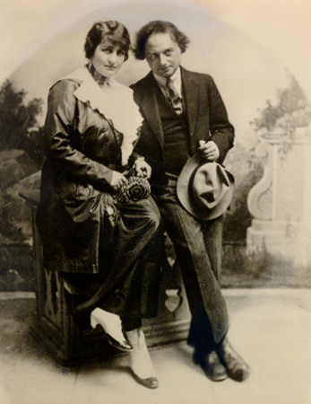

Also in 1917, Blei introduced Werfel to Alma Mahler, the widow of Gustav Mahler and current wife of Walter Gropius. After a passionate affair, a premature son was born to Alma and Werfel in August of 1918. Although Alma divorced Gropius in 1920, she refused to marry Werfel for nine years, primarily because of his Jewish faith. Nonetheless, Alma and Werfel continued to live together, and Werfel viewed Alma as his “giver of life, keeper of the flame.” Indeed, it was during this time that Werfel published his first major novel, *Verdi: Roman der Oper* (*Verdi: A Novel of the Opera* 1924), in which he portrays “the mythical legend of [Giuseppe Verdi],” as he states in the forward. Although Werfel had been entranced with Verdi since seeing *Rigoletto* in 1904, scholars have speculated about the extent to which Werfel’s novel embeds tensions between Werfel and Alma, who preferred the Romanticism and subjectivity underlying Wagner’s music to the symmetry and unity of Verdi’s operas. There is, however, little doubt that Alma’s knowledge of music influenced Werfel’s composition of the novel.

Franz Werfel and Alma Mahler-Gropius, 1919

url: http://www.alma-mahler.at/deutsch/almas_life/lebensorte/alma_in_berlin_3.html

Werfel’s religious struggles and confusions also crystalized during this period, and in 1926, Werfel published a play, *Paul among the Jews: A Tragedy* (*Paulus unter den Juden: Dramatische Legende in sechs Bildern*). This play centers on the conflict between Rabban Gamaliel, a Jewish patriarch, and Paul, a former Jew converted to Christianity, around issues of faith and reason, blind adherence to religious law, and examination of the inner self. In 1929, Werfel publicly – if not personally – declared his religious stance, and in accordance withAlma’s marriage terms, he withdrew from the Jewish community on June 27, 1929. Less than two weeks later, Alma and Werfel were married.

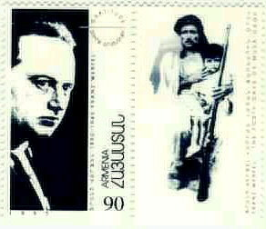

During January and February of 1930, the Werfels traveled to the near East and encountered starving refugees from the Armenian Genocide in 1915. This trip inspired Werfel’s magnum opus, *Die vierzig Tage des Musa Dagh* (*The Forty Days of Musa Dagh*), published in 1933. Even as this work is one of historical fiction, depicting the events surrounding the Turkish persecution of the Armenians, so too did Werfel interweave references to current events, and scholars have suggested that Werfel deliberately paralleled the attitudes leading to the Armenian Genocide with the anti-Semitism of the Nazis, thereby foreshadowing the Holocaust. Although it was published to critical acclaim in many countries, *Musa Dagh* was banned in Germany within the first two months of its publication.

1995 Armenian stamp in honor of the 50th anniversary of the death of Franz Werfel. Werfel is pictured on the left, while the image on the right depicts a scene from *The Forty Days of Musa Dagh*. Stamp designed by Samvel Partamyan.

url: http://www.iatp.am/stamps/nam-1995.htm

In 1938 the Werfels were forced to flee from Austria to Paris, where they remained for a short period before having to flee again in 1940. During this second flight – on their way to Spain in order to catch a boat to America – the Werfels took refuge in Lourdes, France, a small town known primarily as the site where St. Bernadette Soubirous saw visions of the Virgin Mary. While in Lourdes, Franz Werfel’s death was publicized on the British radio, and Werfel vowed that if he made it to America alive, he would write a novel about the life and struggles of St. Bernadette. The resulting work, *Das Lied von Bernadette* (*The Song of Bernadette*) was published in 1941 after the Werfels had safely settled in Los Angeles. In 1943, this novel was subsequently made into a movie, winning four Academy Awards.

Recordings of Werfel reading several of his poems, including “Der schöne Strahlende” are available at: http://www.alma-mahler.at/deutsch/almas_life/werfel.html#

Werfel continued to write and publish while in Los Angeles. His works from this period include the novella *Eine blaßblaue Frauenschrift* (*Pale Blue Ink in a Lady’s Hand*; 1941) and the play *Jacobowsky und der Oberst: Komödie einer Tragödie* (*Jacobowsky and the Colonel*; 1944). On August 26, 1945, Werfel died of a heart attack while correcting the galley proofs of his final book of verse, *Gedichte aus den Jahren 1908-1945* (*Poems from the Years 1908-1945*; published in 1946), at his home in Beverly Hills. His last novel, *Stern der Ungeborenen* (*Star of the Unborn*) was also published posthumously in 1946. Werfel’s body was interred at Rosedale Cemetery; in July of 1975, however, his remains were returned to Vienna for reburial in the Zentralfriedhof.

**Selected List of Works**

**Poetry:**

*Der Weltfreund* (1911)

*Wir sind: Neue Gedichte* (1913)

*Poems* (1945), trans. Edith Abercrombie Snow

*Gedichte aus den Jahren 1908-1945* (1946)

**Drama:**

*Goatsong: A Drama in Five Acts* (1921), trans. Ruth Langner, 1926

*Juarez and Maximilian: A Dramatic History in Three Phases and Thirteen Pictures* (1925), trans. Ruth Langner, 1926

*Paul Among the Jews: A Tragedy* (1926), trans. Peter P. Levertoff, 1928

*Jacobowsky and the Colonel: Comedy of a Tragedy in Three Acts* (1944), trans. Gustave O. Arlt, 1944

**Novels:**

*Verdi: A Novel of the Opera* (1924), trans. Helen Jessiman, 1925

*The Man Who Conquered Death* (1927), trans. Clifton P. Fadiman and William A. Drake, 1927

*The Forty Days of Musa Dagh* (1933), revised trans. Geoffry Dunlop and James Reidel, 2012

*The Song of Bernadette* (1941), trans. Ludwig Lewisohn, 1942

*Pale Blue Ink in a Lady’s Hand* (1941), trans. James Reidel, 2011

*Star of the Unborn* (1946), trans. Gustave O. Arlt, 1946

**References for Further Reading:**

Jungk, Peter Stephan. *Franz Werfel: A Life in Prague, Vienna, and Hollywood*. Trans. Anself Hollo. New York: Grove Weidenfeld, 1990

Mahler-Werfel, Alma. *And the Bridge is Love*. Trans. E. B. Ashton. New York: Grove Weidenfeld, 1990

Steiman, Lionel B. *Franz Werfel: The Faith of an Exile. From Prague to Beverly Hills*. Waterloo, Ontario: Wilfrid Laurier University Press, 1985

Wagener, Hans. *Understanding Franz Werfel*. Columbia, SC: University of South Carolina Press, 1993

-Christian Howard, University of Virginia